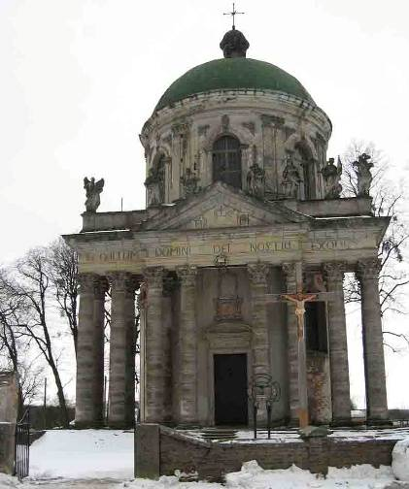

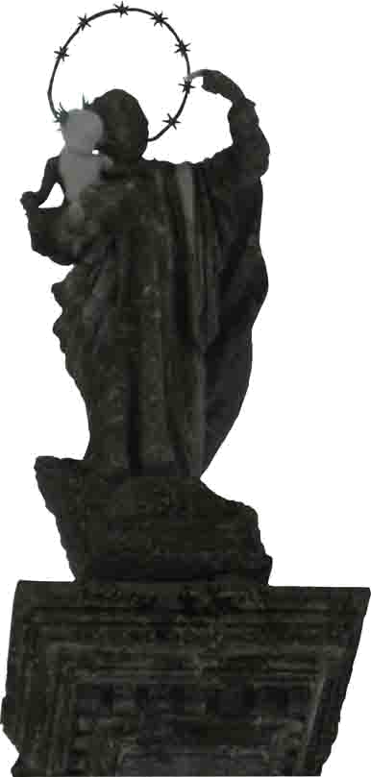

«If they keep silent, the stones will cry out!»

(Lk 19,40)

“If they keep silent, the stones will cry out.”
(Lk 19:40)

The church in Pidhirtsi erected in 1752-1766 to the south of a famous castle sited on a high plateau over the valley of the Styr river.
On the front side the church is enriched by a massive portico with a tympanum and eight sculptures in the attic with the inscriptions “IHS”, “MARIA”, “JOSEPH” and “IN CULTUM DOMINI DEI NOSTRI EXODI”.
Two columns with the statues of saints – St. Joseph with the Child Jesus and the Virgin Mary – situated in front of the church.
Since 2005 one can observe an unprecedented phenomenon on these statues. The statue of little Jesus, whom St. Joseph holds in his arms, began to turn visibly white (a process of self-restoration) and simultaneously, the same happens with the forefinger of St. Joseph pointing at the Child Jesus, notwithstanding the fact that the whole statue is made of the same material. Everybody who visits this pilgrimage place is a witness to this God’s miracle. This started to be seen immediately after the religious superiors of OSBM in unity with Card. L. Husar had issued a prohibition against the recollection held by the Pidhirtsi Basilian fathers, wherein they had preached the living Christ. Looking at the statue, one as if heard Jesus’ words: “If they keep silent, the stones will cry out.” (Lk 19:40)
Through this internal persecution the fathers were led to a task – to fight for Christ and His kingdom with pen and to reveal with courage the truth in the present-day Church.
Not long ago, by God’s Providence, they were consecrated bishops of the UGCC.
May the Pidhirtsi statue be a symbol of the commencing revival of the Church!
(A contribution by the Pidhirtsi pilgrims)

